4-H FASHION REVUE FACT SHEET

Name___________________________________________________________
Address________________________________________________________________________________________________________________________
Parents/ Guardians Names____________________________________________
Brothers & Sisters ( names & ages)_____________________________________ _______________________________________________________________
School Grade______________________________________________________
What are your hobbies?______________________________________________ _______________________________________________________________
School Activities___________________________________________________
4-H Activities_____________________________________________________ _______________________________________________________________
Church & Community Activities________________________________________ _______________________________________________________________
Who do you look up to and why?________________________________________
What do you like about yourself?_______________________________________ _______________________________________________________________
Your favorite place on earth?__________________________________________ _______________________________________________________________
What are your future plans?__________________________________________
Approximate cost of garment?_________________________________________
Give a description of your garment( fabric, style, color, how many pieces, accessories, etc.)_________________________________________________________________________________________________________________________________________________________________________________________________________________________________________________________
4-H Fashion Revue

Constructed Non-Clothing

Please fill out one of these sheets for each category of Fashion Revue in which
you will participate. What you include will be read while you are on the runway.
Thanks for doing this, we are glad you are part of the Revue!

Please describe your constructed item:

Please tell us a little about yourself. For example age, grade in school, what you like to do with your free time, hobbies, other 4H interests, etc.

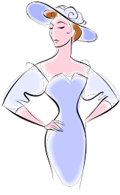
4-H Fashion Revue

Constructed Clothing Item

Please fill out one of these sheets for each category of Fashion Revue in which
you will participate. What you include will be read while you are on the runway.
Thanks for doing this, we are glad you are part of the Revue!

Please describe your constructed item:

Please tell us a little about yourself. For example age, grade in school, what you like to do with your free time, hobbies, other 4H interests, etc.

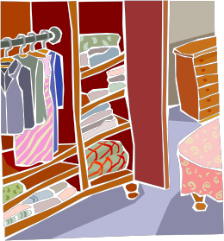

Personal Wardrobe

Please fill out one of these sheets for each category of Fashion
Revue in which you will participate. What you include will be read while you are on
the runway. Thanks for doing this, we are glad you are part of the Revue!

Please describe your favorite outfit from your personal wardrobe:

Please tell us why this outfit is your favorite:

Hobby Clothes

Please fill out one of these sheets for each category of Fashion Revue in which
you will participate. What you include will be read while you are on the runway.
Thanks for doing this, we are glad you are part of the Revue!

Please describe your Hobby Clothes:

Please tell us about your hobbies:

